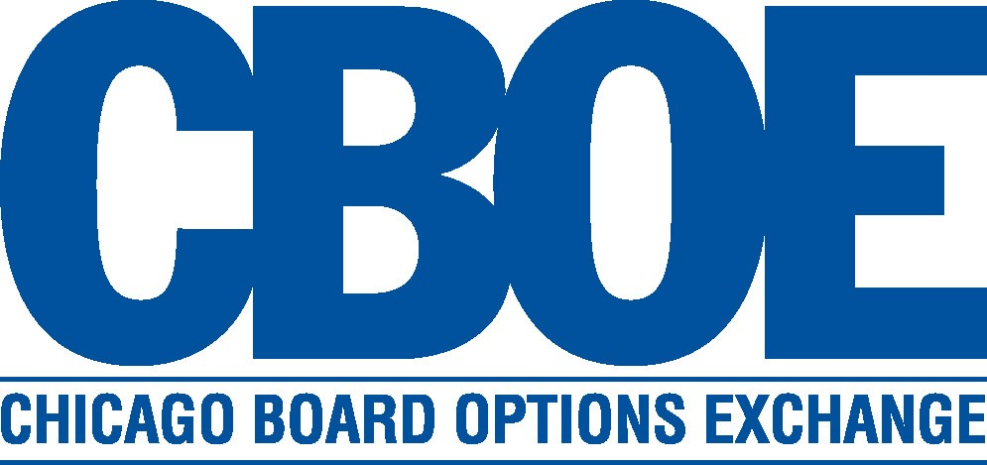

SYSTEMS DIVISION

PROJECT CHARTER

CTMR Test Class Processing

WR #6483

Prepared by: D. Schmitz
Creation Date: 1/4/10

Approved by:

Charlie Hullihan
Market Services

Mark Novak
Systems Division

APPROVED

CBOE CONFIDENTIAL AND PROPRIETARY

Project Charter Distribution List

Staff
Alex Brazhnichenko
Ashraf Ansari
Nikki Brongel
Tom Busch
Steve Chodash
Karen Christiansen
Paul Ciciora
Bruce Currie
Matt Danaher
Alicia Goldberg
Chris Hield
Charlie Hullihan
Sunita Karmakar
Keith Kiley
William Konczyk
Stan Leimer
Thomas Lynch
Indravadan Merai
Anthony Montesano
Mike Neher
Linda Nipper
Mark Novak
John Parkolap
Bob Peterson
Bobbie Piwnicki
Brad Samuels
David Schmitz
Curt Schumacher
Jeff Schweitzer
David Seng
Steve Sinclair
Eileen Smith
Mike Trees
Stella Ulyanov
Jinu Varghese
Ravi Vazirani
Tim Watkins
Monica Wiedlin-Torres
Kerry Winters-Diana
Omarr Woodhouse
Mark Woyna
Ying Zhou

Table of Contents

1) Goal 3
2) Objective 3
3) Business Case 3
4) Strategy 3
5) Tactics Statement 3
6) Project Scope and Approach 3
7) Assumptions and Issues 3
8) Risk Factors 3
9) Patent Consideration 3
10) Cost Analysis 3
11) Benefits 3
12) Environmental Analysis 3
13) Schedule and Dependency Constraints 3
14) Resource Skill Needs 3
15) Product Research 3

PROJECT CHARTER

Goal
The goal of this project is to allow trades on test classes to process through the CTMr system similar to ‘real’ trades.

Objective
The objective of this project is to change CTMr logic to accept and process trades on test classes when both sides of the trade are test firms.

Business Case
Today, trades on test classes flow through all of the various CBOEdirect applications, but get thrown away when they reach CTMr. If someone wants to do a thorough test of a trade on the production system, they must do a real trade on a production class using a production firm and then bust out that trade when they are done. This project will allow for a thorough test of all applications, including CTMr, in the production system while using a test class along with test firms on both sides.

Strategy
The strategy for this project is to enhance CTMr to recognize and process trades that occur on a test class using a test firm on both sides of the trade.

Tactics Statement
This project will be developed following the standard Systems Development Methodology.

Project Scope and Approach

Test Firm Flag:
As part of this project, the concept of a ‘test firm’ will be introduced into the system. The Membership application (now to be known as ‘TPS’ – Trading Permit System) recently implemented the ability to flag a firm as a ‘test firm’, but that functionality has not yet been put into use.

‘Test Trade’ Definition:
For the purposes of this document, a ‘test trade’ will be:

Any trade on a test class where both the Buy executing firm and the Sell executing firm are ‘test firms’.

The CTMr development group will make changes as follows:

- Enhance CTMr to accept and utilize the new ‘test firm flag’ to be sent over the TPS interface.

- Allow test trades into CTMr. These ‘test trades’ should go through the matching process, but not create the records that would be sent to the OCC.

- Modify CTMr to send more error cases to the fatal error screen (instead of rejecting/ignoring them).

  - The following table illustrates the expected new behavior:

Class type: | BUY/SELL Executing Firm type: | CTMr behavior: | Data to OCC?
Test class | Both Test firms | Allow in for CTM processing. | No.
Test class | Both Production firms | Send to Fatal screen | No.
Test class  or  Prod. class | Buy Executing firm is ‘prod’ and Sell Executing firm is ‘test’ or vice versa | Send to Fatal screen | No.
Prod class | Both Test firms | Send to Fatal screen | No.
Prod class | Executing firm of ‘999’ on either executing firm side | Special case – CTMr will not process the trade nor send it anywhere  (same as today). | No.
Test class  or  Prod. class | Invalid firm on either side | Send to Fatal screen (same as today). | No.
Prod. class | Both Production firms | Allow in for CTM processing (same as today). | Yes.

- The processing described in the grid above will also ensure that CTL-D production reports for ‘real’ firms will not contain data related to test trades.
  - However, by default, the CTL-D production reports will contain data for test trades for the firm (or firms) that TPS (Membership) designates as a ‘test firm’ (e.g. ‘998’).
  - ‘Real’ firms will not have the ability to view the report data for the ‘test firm’.

- Ensure that test trade data is not included in any production statistical data.
  - During development of the project, it will be determined which reports contain statistical data so that it can be verified that they are not affected.

- Ensure that the daily CTM purge process will also purge any test trades, matched or unmatched.
  - Note: Production unmatched trades must be manually removed from the system and that will continue to work that way.

The Data Warehouse development group will make changes as follows:

- Enhance Data Warehouse to accept the new ‘test firm flag’ to be sent over the TPS interface.

- Accept test trades from CTMr (they come directly from CTMr – No CDB involvement).
  - DWS currently recognizes ‘test trades’ for CBOEdirect by the fact that the trade is for a ‘test class’ and will also do the same for segregating the test trades created as a result of this project.
  - Note: For the Options session, there will not be any cleared test trades sent from CTMr to DWS, only matched and unmatched test trades.
  - For the Futures and Stock sessions, a single file exists for all trades since they come ‘matched’ to CTMr (i.e. there aren’t any unmatched trades).
  - The test trades should be kept in DWS tables segregated from the tables that are used for statistics gathering, regulatory functions etc. (i.e. the test trades should NOT be stored in the final production Trade History tables with ‘real’ trades).
    - Note: For options that would be OPT_TRADE_HIST_MAST and OPT_TRADE HIST_DTL).
  - For Futures and Stock, a new DWS exception table will need to be created to retain the trades.
  - The test trades from CTMr will be archived similar to the way that Cd test trades are archived.

The Corporate Systems development group will make changes as follows:

- TPS (Membership): Coordinate the assignment of an unused firm number (e.g. ‘998’) to be used for testing by ITG, Help Desk, and Window personnel. The firm name should also be something to the effect of ‘CBOE TEST FIRM’. This pseudo-firm will have all of the characteristics of a ‘real’ firm, but will be considered to be a CBOE test firm. If that firm number actually needs to be used by a ‘real’ firm at some point in the future, ITG will have to make changes to their table settings accordingly.

- CTMi: Allow the display of, and corrections to, the CTMr (non-fatal) test trade records.
  - Only the ADMIN CTMi login (‘000’) should be able to display and alter the test trades in CTMi.
    - Firms will not be able to view the test trades and, therefore, will not be able to alter them.
  - The ADMIN user will be able to make the same post-trade changes as other firm users.
  - The display function should be enhanced to include a filter choice of including or excluding test trades.
  - The test trades should be flagged somehow differently in the display.
  - This will be beneficial for validating new CTMi program loads.

- CTMi – CTMr: New interaction consisting of new queries from CTMi to CTMr by product and firm to determine if a firm or product is valid, test, or invalid.

The ITG group will make changes as follows:

- Alter the table settings that currently use firm ‘999’ to use a new firm number (e.g. ‘998’) that will be considered as a ‘test firm’ in the Membership application.

Assumptions and Issues

- Firm ‘999’ will continue to be set up in Membership as a ‘real’ firm to be used by production firms as a placeholder on the opposite side of the trade (it will not have the ‘test firm’ flag set to ‘on’).
  - Note: Some firms use ‘999’ themselves as a placeholder firm on the contra side of trades so ‘999’ should not be the number that is used for the ‘test firm’.

- The Membership group will have the ability to change the ‘test firm’ setting for a firm intraday.

- This project will affect all sessions, not just options.

- There will be no new flags or columns introduced to designate ‘test trades’.

- There will be no new properties or switches created for this project (other than the ‘test firm’ flag which already exists in TPS).

- Nothing in CBOEdirect will prevent the ‘CBOE test firm’ number from being used on a real product (i.e. not a test class).

  - CBOEdirect will not have access to the ‘test firm’ flag.

- Trades on production classes using test firms will go to the fatal error screen and will never be passed on to the Data Warehouse

- Trades on test classes are already excluded from Cd intraday volume reports, but trades on real classes using firm 999 are not excluded. If a test firm (e.g. 998) is used to create a trade on a real class, it will not be excluded from Cd intraday volume reports.

- Test trades will be allowed into CTMr both at morning checkout time and intraday as well as during weekend testing sessions.

- Any trades left in the ‘fatal screen’ at the end of the day will be purged (as they are today).

- Today, CBOEdirect test trade records go through CDB, are stored in separate exception tables in the Data Warehouse, and are viewable in CDB via Market Replay for the trade date only. This will remain the same and Market Replay will not be changed to view the CTMr trade history records for this project.

- Test trade data will not be allowed into the Billing system applications.

- The functionality for this project also applies to C2 and the DR site.

Risk Factors

Project Size/Complexity
Low risk –Test trade data will not be reflected in ‘real’ firms’ production trade data reports or statistics (since any trades on test classes that contain a ‘real’ firm on either side will be sent to the fatal error screen). If the test trade data should accidentally get sent out to the OCC, there will be no harm done, as they will reject it (because of ‘invalid class’ and/or ‘invalid firm’).

External Consultants
N/A – External consultants will not be used on this project.

External Connections
N/A – There will be any new connections for this project.

Environmental Changes
N/A – There will not be any new computer hardware or commercial software needed for this project.

Patent Consideration
None.

Cost Analysis
Total Cost:

Development Group | Developer Months | Cost
Corporate Systems | 2.50 | $25,500
DA Support | 2.00 | $20,400
Data Warehouse development | 3.00 | $30,600
ITG | .75 | $7,650
Regulatory (regression testing) | .50 | $5,100
Server - CTMr | 5.00 | $51,000
Total | 13.75 | $140,250

Hardware/Software Costs
No new Hardware/Software costs are anticipated.

Benefits
The benefit of this project is that more comprehensive trade testing can take place without having to resort to using production classes.

Environmental Analysis
It is anticipated the current environment will support the capacity and other requirements of this project.

Schedule and Dependency Constraints
No constraints or scheduling conflicts are currently known for this project.

Resource Skill Needs
In-house resources have the skills necessary to complete this project.

Product Research
No further investigation of products or vendors will be necessary to complete this project.

